Clinical Lab Specimen Collection Instructions
Vibra Health Lab

CONTENTS OF KIT

- Test Requisition
- Biohazard bag with absorbent material (1)
- Barcode stickers with DOB to be completed (2)

GENERAL INSTRUCTIONS

To ensure safety and validity of the sample it is important to follow the instructions provided below. Use ONLY the tube provided.
  - Use proper PPE and collect the specimen using sterile venipuncture technique.
  - Place one barcode sticker with date of birth completed on the collection tube and one completed barcode sticker on the completed Test Requisition.
  - Transport specimen to the laboratory as soon as possible after collection.
  - Confirm that the information on the requisition (barcode and date of birth) matches the identifiers on the collection container.
  - Place specimen in sealed biohazard bag in the provided clinical pack for pickup by laboratory courier.

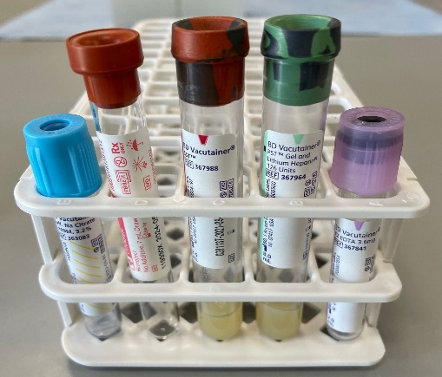
ORDER OF DRAW

It is necessary to draw blood tubes in a specific order, known as “Order of Draw.” This helps to minimize carry over of any additives that may affect subsequent tubes.
If drawing more than one tube, draw tubes in the following order:
- Blue Top
- Red Top
- SST
- Green Top
- EDTA
First Last

SPECIMEN SPECIFIC INSTRUCTIONS

- Blue Top Tubes (Sodium Citrate anticoagulant - used for Coagulation testing)
  - Fill to within 90% of etched line. Do not over- or under-fill as this will cause incorrect test results.
  - Gently invert 6-8 times to allow adequate mixing of blood. Mix blood immediately after collection.
  - Store at room temperature until pickup.
    - PT, PTT and INR are stable at room temp up to 24 hours.
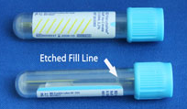
    - D-Dimer is stable at room temp up to 4 hours
    - If testing cannot be performed within the stability window, centrifuge the specimen at 3000 rpm for 15 min, remove and freeze plasma.
  - Do not open tube unless plasma is to be frozen.
  - Criteria for Specimen Rejection:
    - Broken or leaking tube
    - Insufficient sample volume (< or > 90% to etched line)
    - Frozen whole blood
    - Clotted or hemolyzed samples
    - Specimen labeled incorrectly or not labeled

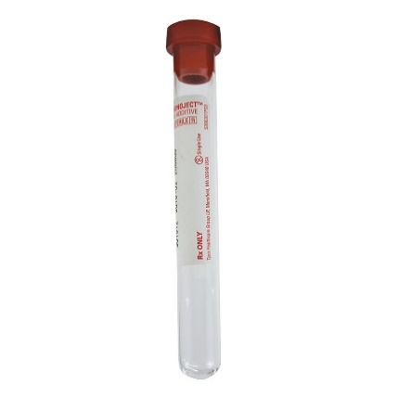
- Red Top Tubes (No anticoagulant - used for some Chemistry testing)
- Allow the specimen to stand upright for at least 15 minutes to clot.
- Centrifuge the specimen at 3000 rpm for 15 minutes.
- Store at room temperature until pickup. Stability varies by test.
- Criteria for Specimen Rejection:
    - Broken or leaking tube
    - Insufficient sample volume
    - Hemolyzed samples
    - Specimen not received centrifuged
    - Specimen labeled incorrectly or not labeled

- SST Tubes (No anticoagulant, with gel separator - used for most Chemistry testing)
  - Allow the specimen to stand upright for at least 15 minutes to clot
  - Centrifuge the specimen for 15 minutes
  - Store at room temperature until pickup. Stability varies upon test.
  - Criteria for Specimen Rejection:
    - Broken or leaking specimen tube(s)
    - Insufficient sample volume (full tube recommended - at least 1 ml required)
    - Specimen not received centrifuged
    - Specimen labeled incorrectly

- Green Top Tubes (Lithium Heparin anticoagulant with gel - used for some Chemistry testing)
  - Gently invert 6-8 times to allow adequate mixing of blood. Mix blood immediately after collection
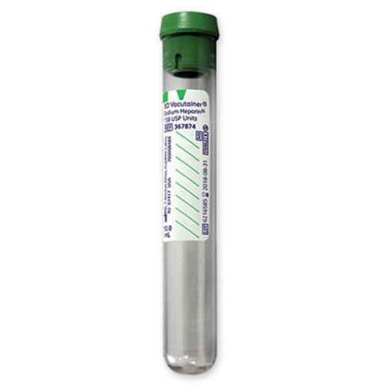
  - Centrifuge the specimen at 3000 rpm for 15 minutes within 1 hour of collection
  - Store at room temperature up to 8 hours, refrigerated up to 12 hours and frozen 3 months
  - Samples can be thawed once
  - Criteria for Specimen Rejection:
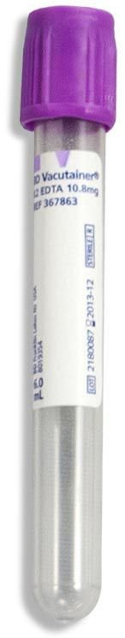
    - Broken or leaking tube
    - Insufficient sample volume
    - Clotted or hemolyzed samples
    - Specimen not received centrifuged
    - Specimen labeled incorrectly or not labeled

- Lavender Top Tubes (used for Hematology, HBG-A1c testing, Ammonia, BNP and
SARS-CoV-2 IgG antibody)
  - Do not centrifuge Hematology and HBG-A1C
  - Store at room temperature until pickup. CBC/DIFF stable at room temp 24 hours
  - Ammonia and BNP – centrifuge the specimen at 3000 rpm for 15 min, remove and freeze plasma within 4 hours
  - Criteria for Specimen Rejection:
    - Broken or leaking specimen tube(s)
    - Insufficient sample volume (full tube recommended - at least 1 mL required)
    - Specimen labeled incorrectly

- Urine Cup (used for Urine Macroscopic, Urine Microscopic and Urine HCG testing)
  - Do not centrifuge
  - Store refrigerated until pickup. Stable refrigerated for 24 hours (urinalysis) and 48 hours (HCG).
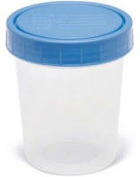
  - Criteria for Specimen Rejection:
    - Leaking or unsuitable specimen container
    - Insufficient sample volume - at least 2 mL required
    - Specimen labeled incorrectly
    - Specimen contamination – (i.e. -lubricants, talc, contrast media, fecal material)

